**Ideation Phase**

**Empathize & Discover**

|  |  |
| --- | --- |
| Date | 19-feb-2026 |
| Team ID | LTVIP2026TMIDS64562 |
| Project Name | Smart Sorting: Healthy vs Rotten Fruits & Vegetables Detection using Deep Learning |
| Maximum Marks | 4 Marks |

**Empathy Map Canvas:**

An empathy map is a simple, easy-to-digest visual that captures knowledge about a user’s behaviours and attitudes.

It is a useful tool to helps teams better understand their users.

Creating an effective solution requires understanding the true problem and the person who is experiencing it. The exercise of creating the map helps participants consider things from the user’s perspective along with his or her goals and challenges.

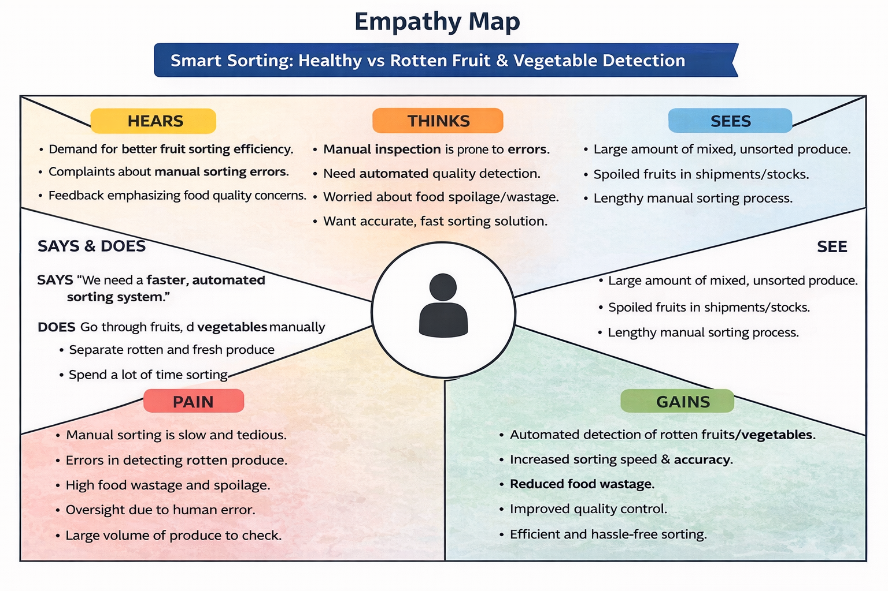

**USER — Food Quality Inspector / Store Manager / Consumer**

| **Section** | **Content (As per your project)** |
| --- | --- |
| **SAYS** | - "We need faster fruit quality checking."  - "Manual sorting takes too much time."  - "We want fresh products for customers."  - "We must reduce food waste." |
| **THINKS** | - Manual inspection may cause mistakes.  - Automated detection can improve efficiency.  - Technology should help identify rotten fruits quickly.  - Quality control is important for customer satisfaction. |
| **DOES** | - Checks fruits manually.  - Separates rotten and fresh produce.  - Monitors product quality.  - Uses available tools to reduce spoilage. |
| **FEELS** | - Frustrated with time-consuming manual work.  - Concerned about product quality.  - Stressed about errors in inspection.  - Interested in automated smart solutions. |

